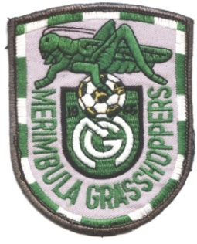

The Karl Posselt Cup 2023
Sept 30 – Oct 1
Expression of Interest

Age Group: Association or Club Team:

Team Name: Male/Female:

Team Uniform Colours

Shirt: Shorts:

Socks:

Change Shirt: Change Shorts:

Change Socks:

Team Contact:

Email Address:

Contact Number:

Would your team be available to play on Friday or Saturday evening? Y/N

Would your team like to take advantage of team dinner arrangements at Club Sapphire on Saturday evening? Y/N

Please complete and return email to peterees55@yahoo.com.au before close of nominations on

Friday September 1st 2023

The team entry fee of $250 must be paid within 7 days of notification of acceptance.

We hope to welcome your team to Merimbula and our 2023 Karl Posselt Cup.

